Title: Deep learning models for predicting embryonic developmental dynamics and mutant trajectories from high-resolution microscopy

Alternatives:
- Learning embryonic developmental dynamics through multi-field autoencoders and conditional convlstm predictive models
- Predicting normal and mutant developmental trajectories using deep spatiotemporal models and perturbation-conditioned forecasting
- AI-based simulation of early embryogenesis under genetic perturbations using physics-aware representations and conditional temporal models

Author list
¹, Hernán Morales-Navarrete²

Affiliations
¹
2 Bio-Cheminformatics Research Group, Universidad de Las Américas, Quito, 170504, Ecuador
# Correspondence:hernan.morales@udla.edu.ec

Abstract

Motivation:
Early embryonic development emerges from nonlinear, coordinated changes in cell morphology, motion, and organization. Genetic perturbations such as BMP and Nodal mutants dramatically alter these dynamics, but predicting these trajectories remains an open challenge.
Dataset:
Extracted embryo tracks (2hpf–16hpf) from the high-resolution microscopy dataset XXXX, including:
- Wild type (WT)
- BMP pathway mutants
- Nodal pathway mutants
Methods:
- Multi-field convolutional autoencoders to learn compact developmental representations
- Spatiotemporal ConvLSTM models to predict future embryo states
- Conditional ConvLSTM, taking a genetic-perturbation vector (00 WT, 10 Nodal−/−, 01 BMP−/−)
- Capability to start from normal embryos and predict mutant evolution by changing condition vector at arbitrary times
Key findings (fill)
- Latent space separates WT, BMP, and Nodal mutants
- Early prediction of developmental deviation
- Conditional models successfully simulate switching from WT → mutant trajectory
- Quantitative improvement in VRMSE, structural similarity, and morphodynamic consistency
Conclusion:
Deep learning enables predictive modeling of early development and perturbation outcomes, offering a generative framework for in silico embryo simulations.

Introduction
1.1 Embryonic Development and Genetic Perturbations
- Dynamics during 2–16 hpf: blastula → gastrulation
During the first day of life, a zebrafish embryo undergoes a breathtaking transformation, following a highly conserved script shared across all vertebrates. Our focus is on the period between roughly 2 and 16 hours post-fertilization (hpf), during which the embryo transitions from a simple ball of cells into a structure with established body axes. These stages correspond to the blastula, gastrula, and early segmentation periods:
Blastula (approx. 2.25 to 5.25 hpf): The embryo starts as a cluster of cells (the blastoderm) sitting atop the large yolk cell. The blastoderm begins a sweeping movement called epiboly, gradually spreading down to cover the yolk (Kimmel et al., 1995).
Gastrula (approx. 5.25 to 10 hpf): This is the crucial reorganization phase. The initial cell ball is rearranged into the three primary germ layers (ectoderm, mesoderm, endoderm), and the fundamental body axes (head-to-tail and dorsal-ventral) are established. The formation of the embryonic shield, analogous to the organizer in other vertebrates, marks this transition (Kimmel et al., 1995).
Early Segmentation (approx. 10 to 16 hpf): This is when the embryo begins forming distinct repeated structures, like somites, which give rise to muscle, vertebrae, and other trunk structures (Kimmel et al., 1995).
Zebrafish are an outstanding model for studying these processes because they are easy to breed, produce large clutches of embryos and, most importantly, are transparent, making them ideal for live imaging and high-content developmental studies. The developmental pathways observed in zebrafish, especially those governing axis formation, are considered evolutionarily conserved, reflecting mechanisms already present in the common ancestor of bony fishes and land vertebrates (Kimmel et al., 1995).
- Roles of Nodal and BMP pathways
Two key signaling pathways, Nodal and BMP (Bone Morphogenetic Protein), act as master conductors orchestrating early development and germ layer patterning.
Nodal Signaling:
This pathway is essential for specifying the inner germ layers. Nodal ligands such as squint and cyclops drive the formation of mesoderm (muscle, bone, heart) and endoderm (gut, liver) and help establish anterior organizing structures that shape the head and trunk (Hagos & Dougan, 2007).
If Nodal activity is lost or severely reduced, the embryo fails to properly specify and move mesendodermal tissues. This produces severe defects such as cyclopia, absence of endoderm, and loss of anterior mesoderm and prechordal plate (Hagos & Dougan, 2007).
BMP Signaling:
BMP is the primary regulator of dorsal-ventral patterning. It determines which tissues form dorsally (e.g., neural and notochordal tissues) versus ventrally (e.g., blood, fin fold, epidermis). It also contributes to posterior body elongation and tailbud morphogenesis (Row & Kimelman, 2009).
When BMP is perturbed, embryos display strong patterning defects, most noticeably in the tail and trunk, including altered posterior morphology, shortened axes, and shifts in the dorsal-ventral balance (Row & Kimelman, 2009).
- Why their disruptions lead to strong phenotypic divergence
A key challenge in early development is that Nodal and BMP act within a very narrow developmental window, at least on the set time (2-16 hpf). It leads that small changes in their activity can become a largeee phenotypic divergence.
Nodal mutans diverge early because mesoderm specification fails at the onset of gastrulation, leading to the loss of organizer and also derived structures (Hagos & Dougan, 2007).
BMP perturbations affect later body axis shaping, especially tailbud development and posterior progenitor maintenance during early segmentation (Row & Kimelman, 2009).
- Importance for developmental biology & disease modeling
The features that exhibit the embryos, make early zebrafish development a powerful bridge between basic developmental biology and biomedical applications.
Zebrafish embryos allow researchers to directly link specific signaling pathways (Nodal, BMP, Wnt, etc.) to the concrete morphological outcomes that emerge along a precisely staged developmntal timeline (Kimmel et al., 1995).
The same pathways that guide normal embryogenesis are frequently misregulated in adult tissues, contributing to cancers, congenital defects, abnormal proliferation and defectivee migration. Understanding their roles during embryogenesis provides fundamental insight into disease mechanisms (Poulain et al., 2006; Capek et all, 2023).
Recent work, most notably EmbryoNet, demonstrates how deep learning can exploit the rich morphology of zebrafish embryos to automatically link early phenotypes to specific pathways perturbations across millons of images, enabling powerful applications in drug screening and high-content analysis (Capek et all, 2023).
1.2 Imaging Dataset
For this study, we used the publicly available zebrafish embryonic development imaging dataset from University of Konstanz (EmbryoNet). The dataset comprises 53 temporal series, where each is a TIFF file containing 450 grayscale frames of 200x200 pixels, downsampled from the original 12-bit, 2,048×2,048 pixel acquisitions. The embryos belong to three genetic conditions: wild type (WT, 18 samples), and mutants of the BMP (16 samples) and Nodal (19 samples) signaling pathways. For model construction, a development set of 41 embryos (14 WT, 15 Nodal, 12 BMP) was defined, which was randomly split into 80% for training and 20% for validation. The remaining 12 embryos (4 per condition) were reserved for testing the model.
The original time-lapse images were acquired using an ACQUIFER Imaging Machine with precise environmental control. For comprehensive details on the microscopy parameters, including the objective, camera specifications and exposure settings, please refer to the official dataset documentation.

1.3 Deep Learning and Development Prediction
Problems in the field:
- High-dimensional phenotypes → difficult to model
Studying how an embryo develops using live videos from a microscope is a huge challenge for computers. The main difficulty is that each embryo creates a massive amount of complex data, that we call a high-dimensional phenotype. This means you have hundreds of video frames, and in each frame, there are tiny, important changes happening in the shape of the cells, how dense the tissue is, the overall symmetry, and how the tissues are organized. Traditional computer methods, like old-fashioned statistics or basic image software, simply are not powerful enough to handle this level of complexity. They struggle to summarize this huge amount of changing visual data into a small, meaningful number that you can actually use to measure or compare the embryos reliably. With modern microscopes producing millions of images per experiment, manual curation becomes impossible, which is why deep learning has become essential in developmental studies.
In recent years, neural networks have demonstrated that they can learn nonlinear morphological signatures from raw data. Convolutional architectures in particular have been widely used in high-content imaging screens to detect phenotypes, classify mutants, or score developmental defects (Kimmel et al., 1995). In zebrafish, deep neural networks have already shown remarkable performance identifying subtle morphological abnormalities and linking them to the disruption of genetic pathways (Capek et al., 2023).
Despite the power of deep learning, existing approaches in developmental biology still have significant limitations. The main issue is that most current deep-learning models focus heavily on classification, rather than prediction. They are excellent at determining the phenotype an embryo currently has, but they fail to predict how that embryo will evolve over time (Goodfellow et al., 2016; Kimmel et al., 1995).
- No predictive models across genetic conditions
There is also a big missing piece in the field related that we do not have good computer models that can predict how development will proceed when there is a fault in different genes. Currently, if a model is trained only on healthy embryos (Wild Type, or WT), it usually fails when you show it an embryo with a problem in a key pathway like Nodal or BMP. The reverse is also true, a model trained on one type of mutant often cannot predict what will happen with a different mutant. This happens because these systems tend to overfit, meaning they memorize the details of the specific fault they were trained on, instead of learning the basic, shared rules of development (Pawlowski et al., 2016). This is especially difficult because problems with pathways like Nodal and BMP result in embryos that look very similar, making it hard even for human experts to differentiate it. Developing a predictive model that can understand how different gene faults change the flow of development would be a major success.
- No “counterfactual developmental forecasts”
1.4 Contributions
Updated to your project:
- Pipeline for extracting full developmental tracks (2hpf–16hpf)
- Multi-field autoencoder analysis of morphology trajectories
One key contribution of this work is the development of a multifield convolutional autoencoder that learns a compact representation of embryo morphology across the 2-16hpf stages. The model will focus on capturing the continuous developmental trajectory from blastula through gastrula and early segmentation. We expect the autoencoder preserves smooth tissue boundaries and ralistic mospholgy, producing latent features that reflect genuine developmental structures.
When the model is finished the use of PCA and UMAP techniques will show the latent vectors form temporal paths and naturally separate WT, Nodal and BMP embryos. This matches known biology as Nodal mutants diverge early during mesendoderm formation (Hagos & Dougan, 2007), and with BMP mutants deviate later during posterior patterning (Row & Kimelman, 2009). These results show that the autoencoder can successfully capture the morphology of each genotype and provides the helps us to provide the principles for the predictive models developed later in the project.
- ConvLSTM prediction models
- Conditional ConvLSTM for genetics-conditioned forecasting
Our second methodological contribution is a spatiotemporal forecasting model based on a multi-layer Convolutional Long Short-Term Memory (ConvLSTM) architecture. This model predicts the next morphological state of an embryo given a short window of past frames. Specifically, we designed a three-layer ConvLSTM network that takes sequences of 10 past frames and predicts the subsequent frame. The network successfully models continuous tissue rearrangements and shape fluctuations across all three genetic backgrounds (Wild type, Nodal-deficient, and BMP-perturbed), demonstrating that its forecasting ability generalizes independently of the embryo’s developmental condition. However, its predictive accuracy degrades under autoregressive predictions, indicating that the architecture is well-suited for short-term forecasting but does not reliably extrapolate long-range development trajectories.
- Ability to simulate “what-if” scenarios
(e.g., normal → mutant switch at t = X)

Methods

2.1 Data Processing
Students fill:
- Extraction of individual embryo tracks
- Downsampling and segmentation applied
- Normalization / cropping strategy
- embryos per class (WT, Nodal, BMP)

We processed each raw grayscale time-lapse microscopy sequence together with its corresponding binary segmentation masks through a multi-stage pipeline to ensure spatiotemporal consistency and isolate the embryonic region of interest.

For every frame, we first performed drift correction using phase correlation. Mechanical stage drift and organismal displacement introduced frame-to-frame motion throughout the embryo recordings. To mitigate this, we estimated the relative translational shift (Δx, Δy) between consecutive frames (t and t-1) using subpixel phase cross-correlation. By accumulating these frame-to-frame shifts starting at t = 0, we obtained the global drift trajectory. We then realigned both the raw images and the segmentation masks via Fourier-domain shifting, stabilizing the embryo’s position throughout the entire sequence.

Next, we compute a temporal Maximum Intensity Projection of the drift-corrected segmentation masks to identify the spatial union of all areas occupied by the embryo during its development. We extracted a bounding box enclosing this region, expanded it by a 5% safety margin, and applied it to all frames. This generated a spatially consistent view that encompasses the entire morphogenetic event while removing background regions lacking biological information.
We then applied the segmentation masks to the via element-wise multiplication, setting all pixel values outside the embryo boundary to zero. The cropped and masked sequences were subsequently resized to a fixed resolution of 128 x 128 pixels using bilinear interpolation.

Finally, we performed a global normalization per embryo stack. The processing scaled the pixel intensities of the entire stack to [0,1] range using the global minimum and maximum pixel values of the full sequence. The results of the multi-stage pipeline data processing applied to raw data can be appreciated in Video 1.

The complete dataset comprises 53 individual embryo tracks distributed across three experimental conditions: 18 samples of Wild Type (WT), 19 samples of Nodal-deficient (Nodal), and 16 samples of BMP-perturbed (BMP). We split the data into a development set and a test set. The development set consisted of 41 embryos (14 WT, 15 Nodal, and 12 BMP) and was used for model construction; an 80:20 random partition of this set generated the training and validation subsets, respectively. To evaluate the model’s generalization capability on unseen biological samples, we preserved the remaining 12 embryos (4 WT, 4 Nodal, and 4 BMP) for a final performance test.

2.2 Multi-field Autoencoders
Architecture

In this part of the project, we used autoencoders that are a clever type of neural network wich teach the computer how to create a highly compact path of each embryo image.
The core idea is simple and is related to the raw embryo frames that are huge, pixel-dense, and difficult to analyze or compare directly, so the autoencoder's job is to take that complex image and compress it into a much smaller digital summary, known as the latent space vector.
Even though this vector is tiny, it is designed to keep the most important biological information intact, capturing things like the overall embryo shape, its symmetry, and the progression of development over time. This compressed representation is vital because it lets us easily compare the three different genetic conditions (WT, BMP mutant, and Nodal mutant) and also we expect any differences in their physical form should become clearly visible in the latent space.

Two AEs:
We experimented with two main types of autoencoders:
A) Simple Autoencoder
- convolutional AE
- Latent dimension: (fill)
- Loss: MSE or SSIM + MSE
This was our foundational model. It simply had an encoder that shrinks the image down to the latent vector and a decoder that tries to perfectly reconstruct the original image from that vector. It was trained using standard metrics like Mean Squared Error (MSE) and Structural Similarity Index (SSIM), but finally we decided to maintain (SSIM). After testing different compression levels (latent dimensions), we settled on a size of 128 dimensions. This worked well because our cropped images were 128 x 128 pixels, and this size offered a great balance between achieving high reconstruction quality and keeping the computational cost reasonable.
The model is divided into two symmetric components: the Encoder and the Decoder.
- The Encoder: This part of the network acts as a compressor. It uses a series of convolutional layers to gradually reduce the spatial dimensions of the image (from 128x128) while increasing the number of feature maps. This process forces the network to ignore noise and focus on the most important biological patterns, eventually flattening the data into a 128-dimensional latent vector.
- The Decoder: This part tries to reverse the last process. It takes the 128-dimensional summary and features, and uses transposed convolutional layers to reconstruct the original image. By comparing this reconstruction to the original frame using the SSIM loss, the model learns to refine its internal representation until it can perfectly capture the embryo's shape and developmental state.

(B) Physics-Aware / Biology-Aware Autoencoder
Constraints applied on reconstructions:
- Smoothness / morphology continuity penalties
- Structural penalties (e.g., boundary preservation)
- Positivity of intensity / density
- Spatial consistency losses
(These are adapted biology-friendly constraints similar to physics-aware constraints in previous paper.)B) Physics-Aware / Biology-Aware Autoencoder

Constraints applied on reconstructions:

Smoothness / morphology continuity penalties

Structural penalties (e.g., boundary preservation)

Positivity of intensity / density

Spatial consistency losses

(These are adapted biology-friendly constraints similar to physics-aware constraints in previous paper
Training procedure
- Data augmentation
To ensure our autoencoders learned the general concept of an embryo, rather than just memorizing the images they saw during training, we used several data augmentation techniques. These methods slightly modified the training images in controlled ways, helping the model generalize across different visual conditions.
We applied a combination of spatial and intensity-based adjustments, exclusively to the training set:
Random Horizontal Flips: With a 50% chance, we flipped the embryo images horizontally. This simple step exposed the model to mirrored versions of the embryo, teaching it that left–right symmetry is normal and preventing it from becoming dependent on one fixed orientation.
Random Rotations: We introduced rotations up to 180°. This simulated the real-world scenario where zebrafish embryos are captured at arbitrary rotational angles during microscopy acquisition, ensuring the model could recognize the embryo regardless of its orientation in the frame.
ColorJitter: This involved adding small, random variations in brightness and contrast. This augmentation was critical for mimicking slight differences between various imaging sessions or microscope settings.

Latent Space Evaluation
Students fill:
- PCA / UMAP of latent vectors
- Separation of classes (WT, BMP, Nodal)
- Temporal organization in latent space
- Biological interpretation:
  - Early divergence in Nodal mutants?
  - Late divergence in BMP?

After training both models, we needed to see if the latent vectors were actually capturing meaningful data. We did this by analyzing the latent space using dimensionality reduction techniques like Principal Component Analysis (PCA) and UMAP. This process was done after training was complete, ensuring the latent vectors were stable.
By reducing the vectors down to just two dimensions, we want to visualize how the embryos cluster and move over time. We expect that embryos tend to follow smooth, continuous temporal trajectories as they develop. More importantly, the WT, BMP, and Nodal mutants should start forming distinct clusters. This will show us that the autoencoder are successfully capturing not only the general developmental morphology but also the key biological differences between the genotypes. We also constantly check its performance on the test set to confirm the autoencoders are generalizing effectively handle brand-new, unseen embryos.
2.3 Temporal Prediction Models
Model 1: ConvLSTM
Fill:
- Input tensor (sequence length, H, W, channels)
- Multi-field prediction
- Rollout strategy
- Training schedule: one-step vs multi-step

We implemented a multi-layer Convolutional Long Short-Term Memory (ConvLSTM) network to model short-term morphodynamic evolution of the embryos. The model received as input a tensor (B, T, C, H, W), where B is the batch size, T is the length of the sequence, C=1 is the grayscale channel, and (H, W) represents the spatial resolution of 128 x 128 pixels.

The architecture (Figure 5A) consists of three stacked ConvLSTM layers with hidden dimensions of 32, 32, and 64 channels, respectively. Each preserves the full spatial resolution of the input using 3 x 3 convolutional kernels and maintains its own hidden and cell states throughout the temporal sequences. For each step t, each ConvLSTM layer concatenates the current input (or the output of the previous layer) with its previous hidden state to compute the input, forget, output, and candidate gates. These gates function as the network’s selective memory system (Figure 5B). They enable the model to dynamically decide which spatial features to retain and which to discard from previous frames. By stacking three recurrent convolutional layers, the model progressively integrates information across spatial and temporal scales.

To generate the prediction, the hidden state of the final ConvLSTM layer at the last time step is projected back into image space using a 3 x 3 convolution followed by a sigmoid activation function. This ensures the output is a normalized prediction in the [0,1] range, matching the input data representation.

This model was trained and validated using a one-step-ahead forecasting regime, optimizing the network to predict frame t + 1 given the ground truth history of the past 10 frames. However, to assess the model’s generalization capabilities on the test set, we employed two inference protocols:

- One-Step Prediction: We evaluated the model’s ability to predict the single next frame, always using the ground truth past frames. This measures the network’s immediate accuracy across all developmental stages.
- Autoregressive Prediction: To test long-term stability, we switched to a closed-loop inference mode. Here, the model’s prediction for t + 1 is fed back into the input window (displacing the oldest frame) to predict t + 2. This recursive process forced the model to rely on its own generated history to simulate developmental trajectories.

The training loss combined three complementary terms: (i) a Mean Squared Error (MSE) loss for pixel-level accuracy, (ii) a Gradient-Difference loss to penalize blurring and preserve edges, and (iii) a Structural Similarity (SSIM) loss to preserve global morphological coherence. The total loss was computed as a weighted sum: L_total = 0.6*L_MSE + 0.2*L_grad + 0.2*L_SSIM.

Model 2: CNextU-Net + Attention
Fill:
- Based on ConvNeXt blocks
- Skip connections
- Spatial attention to emphasize morphological regions
- Advantages for high-resolution embryos

2.4 Conditional ConvLSTM
Goal: Predict mutant developmental trajectories from WT initial conditions.
Condition Encoding
One-hot vector:
- WT = 00
- Nodal mutant = 10
- BMP mutant = 01
Architecture Integration
Two options (students choose or describe both):
- Concatenate condition vector with input tensor
(repeat across spatial dimensions)
- Inject condition into hidden state of ConvLSTM
Applications
- Predict Nodal mutant phenotype from WT starting point
- Predict BMP mutant phenotype from WT
- “Switch condition at t = X” experiments:
  - Start WT
  - At t = X, change condition → system evolves as mutant
Training Strategy
Fill:
- Mixed batches containing WT and mutant sequences
- Condition-supervision
- Curriculum for long-term stability

Results

3.1 Representation Learning
Reconstruction Error
- Compare simple AE vs biology-aware AE
- Show improvement in structural preservation
In order to see how well our system learned, we looked at how accurately it could recreate images of embryos at different stages. We used an autoencoder that works by squeezing the image data into a simplified code and then expanding it back out. This helped us check if the model understood the important details of the embryos evolution during the period 2-16 hpf.

The model did a great job recreating the embryos during their early stages. As the embryos grew more complex and started developing segments, the error rate went up slightly but this was just because there were more details to track, not because the model was failing. When we looked at the images, we could see that the model captured the overall shape and internal patterns perfectly, even if it softened some of the finer textures.

During comparison we noticed that the normal (wild-type) embryos were easier for the model to recreate than the mutated ones. The mutated embryos had more variety and unpredictable shapes, which made it harder to compress them into a simple code. Overall, this shows us that the model is not just looking at random pixels but it is actually picking up on real biological changes. Essentially, the more complex or unusual an embryo is, the harder it is for the model to perfectly recreate it.

Latent Space Organization
Students fill:
- WT, BMP, Nodal clusters in latent space
- Trajectories in latent space over time
- Divergence timing across mutants

When we wanted to see how the model organizes what it learn, we used a few different tools. We found that the information about the shapes of embryos was not hidden in just one or two spots. Instead, the details were spread across the entire system. We used two mapping tools, PCA and UMAP, to look inside and see how it organized the information. We discovered that the embryos were automatically sorted into separate groups based on their genetics. Even though we never told which embryo belonged to which group, it naturally recognized the differences between the normal and mutated types.

Importantly, when latent representations were ordered temporally, individual embryos followed smooth and continuous trajectories through latent space. WT embryos exhibited compact, smoothly curved trajectories consistent with orderly morphogenesis. In contrast, BMP and Nodal embryos followed trajectories that diverged in direction and curvature, indicating altered developmental dynamics rather than isolated morphological outliers.

We used the main trend in our data (PC1) to see exactly when the different embryos started looking different. While the normal (WT) embryos stayed consistent, the mutated ones began to drift away at different times. The Nodal mutants changed very early on, during the first stages of growth. The BMP mutants, however, did not show major changes until much later.

Biological Interpretation
- BMP mutants deviate in axis elongation features?
- Nodal mutants deviate in germ layer symmetry features?
- Early detection of mutant phenotypes based on latent shift

Even though we did not tell the model what to look for, the patterns it found match perfectly with what we already know about biology. For example, the Nodal mutants drifted away early in the data because that gene is responsible for the very first steps of a develop of embryos. On the other hand, the BMP mutants changed later on, which makes sense because those genes handle the final shaping.

We can see that our model is a powerful tool for catching genetic issues early. By looking at how the data shifts in its own internal map, the model can spot mutations before they are even visible to the human eye. This is exciting because it means we can use this type of tool to screen embryos early on, compare how different species grow, and measure exactly how much a genetic change affects it development.

3.2 Temporal Forecasting (ConvLSTM & CNextU-Net)
Prediction Accuracy
Students fill:
- VRMSE vs ground truth
- SSIM or structural metrics
- One-step vs multi-step predictions
- Failure modes (temporal drift, loss of structure)
Qualitative Rollouts
- Predicted embryo shape progression
- Compare WT vs Nodal vs BMP rollouts
- Stability up to 14hpf or 16hpf

3.3 Conditional Prediction (Conditional ConvLSTM)
Predicting Mutant Dynamics from WT Initial State
Students fill:
- Quantitative error reduction when condition is used
- Ability to simulate “counterfactual mutants”
- Biological plausibility of predicted mutant shapes
Condition Switching Experiments
- Show sequence where WT → Nodal mutation at t = 8hpf
- Show differences in predicted:
  - cell movement patterns
  - tissue deformation
  - axis formation
Biological Insights
- Which mutants diverge earliest?
- Can the model foresee mutant phenotype before it becomes visible?

We evaluated the predictive capabilities of the ConvLSTM model on the test set under two distinct regimes:

One-Step-Ahead Forecasting: We first evaluated the model’s ability to predict immediate morphodynamics under the one-step forecasting regime, where the model predicts the next frame given a ground-truth context window. Qualitatively, the model generates highly realistic predictions that preserve the structural integrity of the embryo boundaries and internal tissue texture. As shown in the representative rollouts of Wild Type (Video 2), BMP-perturbed (Video 3), and Nodal-deficient (Video 4), the predicted frames remain sharp and indistinguishable from the ground truth across the developmental timeline (2-16 hpf).

Quantitatively, the error metrics indicate that the model’s performance is robust and consistent across biological conditions. The instantaneous MSE, gradient difference, and Structural Dissimilarity (1-SSIM) curves (Figure 7A, 7B, 7C) exhibit a flat trend with no significant positive slope, confirming that the model does not fail to predict during the morphogenesis process. Crucially, the shaded Standard Error of the Mean (SEM) regions for all three genotypes overlap throughout the majority of the developmental window. This statistical overlap suggests that the ConvLSTM has learned generalized biological rules of embryo development that are phenotype-independent.

Autoregressive Forecasting: In contrast to the stability of the one-step regime, long-term trajectory generation reveals the limitations of the model’s internal memory. When switched to autoregressive inference (where the model feeds its own predictions back into the input), we observe a progressive degradation of morphological structure.

The quantitative degradation curves (Figure 7D, 7E, 7F) show a steady accumulation of error over the forecast horizon. The MSE, gradient and SSIM Loss increase monotonically before reaching a saturation threshold. Visual inspection of the autoregressive rollouts for Wild Type (Video 5), BMP (Video 6), and Nodal (Video 7) reveals that this saturation corresponds to a fading phenomena. As the prediction horizon extends, the model loses spatial details, causing the embryo’s pixel intensity to gradually decay toward zero (black frames).

These results indicate that while the ConvLSTM excels at capturing immediate temporal gradients, it struggles to maintain a persistent global representation of the embryo’s structure over long sequences.

Discussion

• Interpretation of latent structure in biological terms
• Why conditional models outperform unconditional ones
• Limitations of dataset (e.g., noise, sampling rate)
• Data imbalance across mutant types
• Future directions:
- Use 3D ConvLSTM
- Integrate cell tracking
- Physics-informed constraints
- Cross-species generalization

Data Availability

Code Availability

- GitHub repo
- Script list:
  - AE training
  - ConvLSTM & conditional ConvLSTM
  - Evaluation scripts

Acknowledgements

Author Contributions Statement

Competing Interests Statement
The authors declare that they do not have competing interests.

Figure Legends

Figure 1 — Dataset & Preprocessing Overview
Contains:
- Example WT/BMP/Nodal embryo frames 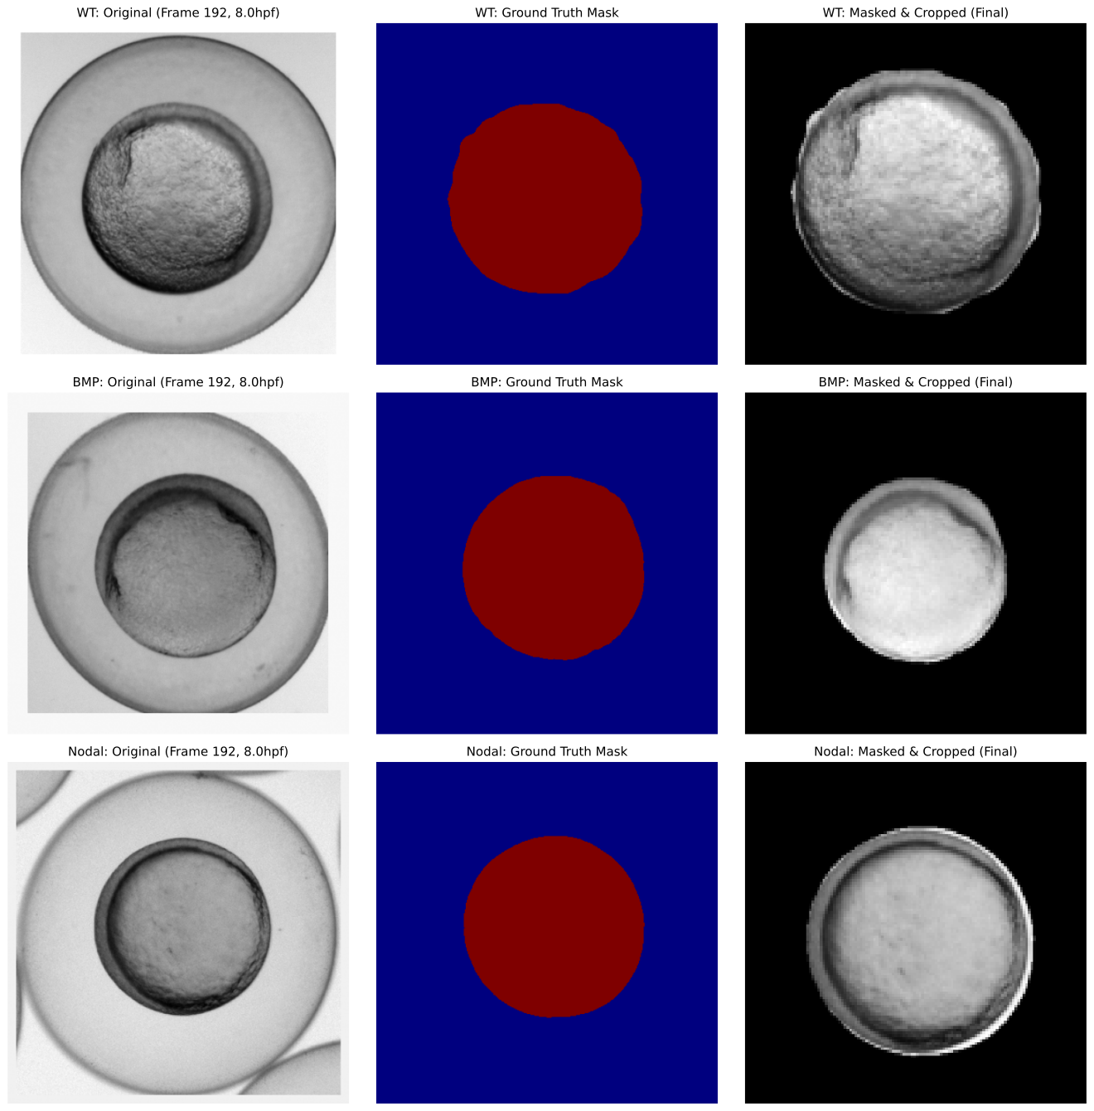
- 2–16hpf timeline diagram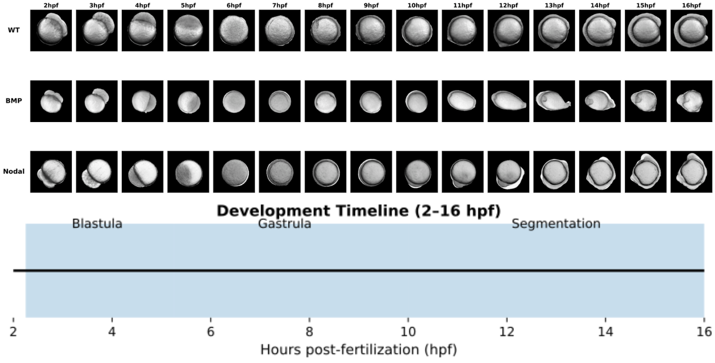
- Preprocessing pipeline (cropping, normalization, tracking extraction)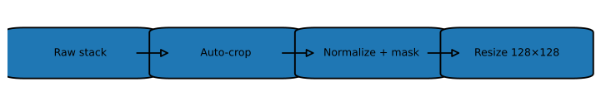
Figure 2 — Autoencoder Architectures
Contains:
Simple AE diagram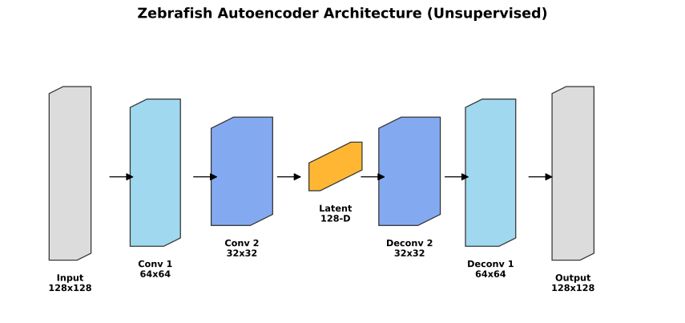
Biology-aware AE with constraint modules
Latent dimension illustration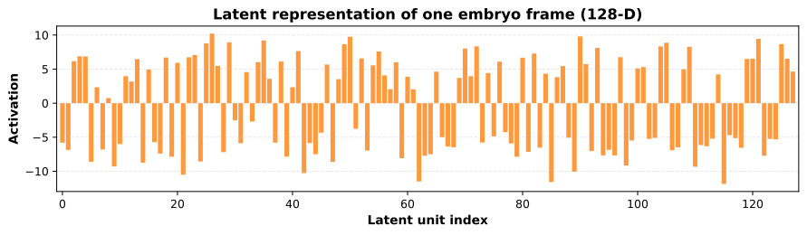
Figure 3 — Reconstruction Results
Contains:
- True vs reconstructed images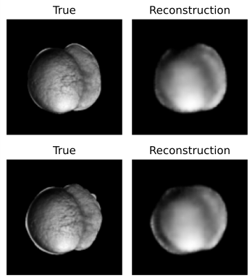
- Different fields/channels
- Simple AE vs constrained AE
- Reconstruction error per stage (2–16hpf)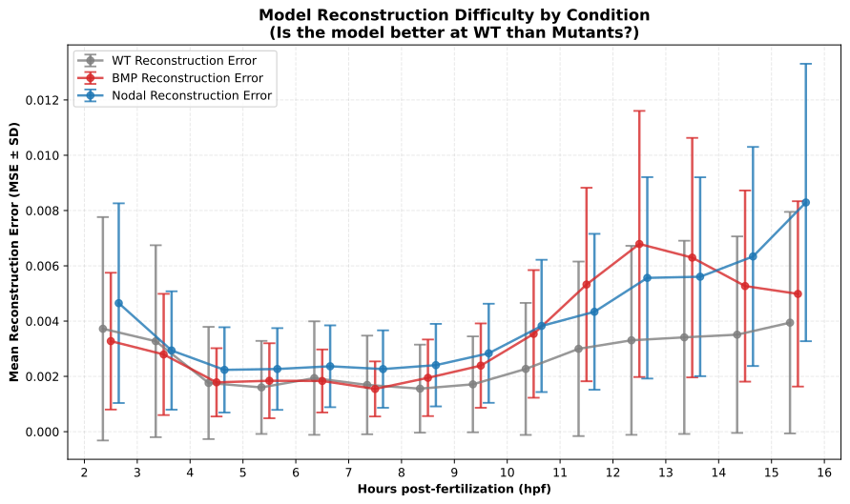
Figure 4 — Latent Space Organization
Contains:
- PCA embeddings colored by:
  - WT
  - BMP
  - Nodal
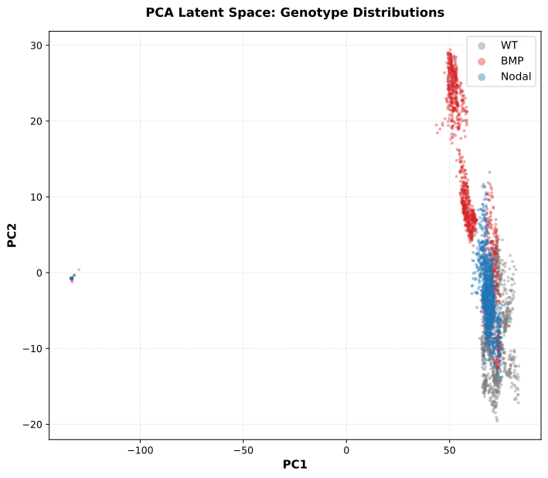
- Temporal trajectory path UMAP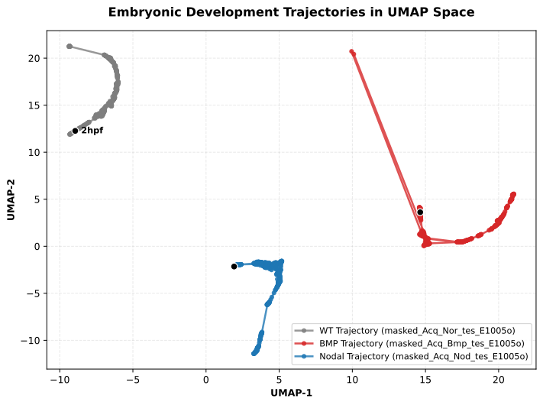
- Divergence timing plots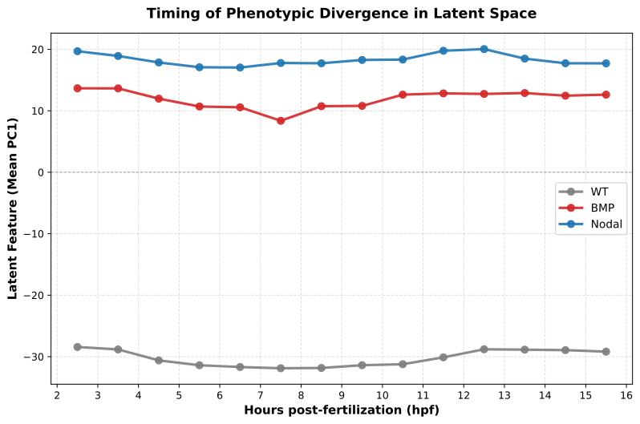

Figure 5 — ConvLSTM Architecture

Contains:
- Input sequence structure
- Multi-field prediction flow
- Memory cell visualization
Figure 6 — CNextU-Net + Attention Model
Contains:
- ConvNeXt blocks
- Attention module
- Multi-resolution skip connections
Figure 7 — Forecasting Accuracy
Contains:
- VRMSE across channels
- Multi-step error curves
- Side-by-side WT vs predicted rollouts
Figure 8 — Prediction Rollouts (WT, BMP, Nodal)
Contains:
- True vs predicted for each genotype
- Key developmental stages highlighted
Figure 9 — Conditional ConvLSTM Setup
Contains:
- Condition vector injection
- Diagram of WT→mutant simulation
- Model architecture
Figure 10 — Condition Switching Experiments
Contains:
- WT initial state
- Switch at t = X
- Model-predicted Nodal or BMP morphologies
- Divergence metrics
Figure 11 — Biological Interpretation of Latent Dynamics
Contains:
- Latent dimension evolution
- Correlation to morphological descriptors
- Early mutant signature detection
Figure 12 — Summary Diagram
Contains:
AE → latent → ConvLSTM → conditional mutation → predicted trajectory
Video 1 — Raw data vs processed data
Contains:

Video 2 — One-Step-Ahead Forecasting for WT embryo
Contains:

Video 3 — One-Step-Ahead Forecasting for BMP-perturbed
Contains:

Video 4 — One-Step-Ahead Forecasting for Nodal-deficient
Contains:
Video 5 —Autoregressive Forecasting for WT embryo
Contains:

Video 6 — Autoregressive Forecasting for BMP-perturbed
Contains:

Video 7 — Autoregressive Forecasting for Nodal-deficient
Contains:

Conclusions

- The unsupervised autoencoder trained, can learn meaningful representations of zebrafish embryonic morphology, capturing continuous developmental progression directly from image data.
- The latent space analysis reveals different organization and distinct developmental trajectories and groups for WT, BMP and Nodal Embryos.
- The proposed ConvLSTM architecture effectively captures the complete cellular dynamics during early embryogenesis (2-16 hpf) for short-term predictions.​
- Quantitative analysis confirms that the model performs equally well for WT, BMP, and Nodal embryos. The network learns generalized principles of morphogenesis for short-term predictions. ​
- Long-term self-looping reveals signal attenuation. Exposure Bias is the primary challenge for future regimes.

References
Kimmel, C. B., Ballard, W. W., Kimmel, S. R., Ullmann, B., & Schilling, T. F. (1995). Stages of embryonic development of the zebrafish. Developmental Dynamics, 203(3), 253–310. https://doi.org/10.1002/aja.1002030302
Hagos, E. G., & Dougan, S. T. (2007). Time-dependent patterning of the mesoderm and endoderm by Nodal signals in zebrafish. Developmental Biology, 305(2), 525–539.
https://doi.org/10.1016/j.ydbio.2007.02.036
Row, R. H., & Kimelman, D. (2009). Bmp inhibition is necessary for post-gastrulation patterning and morphogenesis of the zebrafish tailbud. Developmental Biology, 329(1), 55–63. https://doi.org/10.1016/j.ydbio.2009.02.016
Poulain, M., Fürthauer, M., Thisse, B., Thisse, C., & Lepage, T. (2006). Zebrafish endoderm formation is regulated by combinatorial Nodal, FGF, and BMP signalling. Development, 133(11), 2189–2200. https://doi.org/10.1242/dev.02387
Capek, D., Ibberson, D., Gálvez-Suárez, M., et al. (2023). EmbryoNet: Using deep learning to link embryonic phenotypes to signaling pathways. Nature Methods, 20(6), 815–823. https://doi.org/10.1038/s41592-023-01873-4
Goodfellow, I., Bengio, Y., & Courville, A. (2016). Deep learning. MIT Press. https://www.deeplearningbook.org/
Pawlowski, N., Caicedo, J. C., Singh, S., Carpenter, A. E., & Storkey, A. (2016). Automating morphological profiling with generic deep convolutional networks. bioRxiv, 085118. https://doi.org/10.1101/085118

